Scavenger Hunt for South Asia
Directions: Use the information on pages 538 through pages 605 to answer the following questions as you familiarize yourself with South Asia.
- What countries make up South Asia?
- Who built the Taj Mahal which is located Agra, India, and what was the purpose of building it?
- According to the Geo Data chart, South Asia is a shaped peninsula that juts out into the Ocean.
- What is the world’s tallest mountain? How tall is it?
- What 2 rivers in South Asia are the same length?
- How long are they?____________________
- What is the tallest mountain in the U.S.? __________________________________
- How much taller is Mt. Everest than this mountain? _________________________
- In which (2) countries of modern South Asia was the Indus Valley civilization located? &
- What is a major reason why the civilization developed in this area? ______________________________
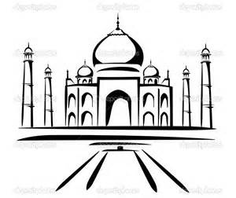
- Rank the countries of South Asia below from most populated to least populated.
LEAST 7.
6.
5.
4.
3.
2.
MOST 1.
- What conclusions can be drawn about South Asia based on the amount of televisions and car?
- What is the longest river in India?
- Compare the size of America and India. Now, compare the size of the population. Write down your observations about the physical size of the countries and the size of their populations.
- What is the major economic activity throughout India?
- What are the three major religions in South Asia?
- What is the largest country as far as landmass is concerned in South Asia?
- What is the name of the tear drop island on the South Eastern coast of India?
- Why is South Asia considered a subcontinent?
- What are the three biggest rivers in South Asia?
- What is the major natural resource coming out of Sri Lanka?
- Even though climates vary throughout South Asia, the entire region share this particular environmental challenge:
- What is the most common temperature in Fahrenheit throughout South Asia?
- What animal was nearing extinction in the 1970s and is now on the protected species list?
- What European country colonized South Asia during imperialism?
- What was the Green Revolution and why was it necessary?
- How many languages are officially recognized by the Indian Constitution?
- What is a very popular string instrument in India?
- During the summer monsoon season, the winds come in from what direction?
- What is the source of major conflict between India and Pakistan?
- India has the world’s highest production on what?
- What is the name of the ethnic group of people that live in the Himalayas and serve as traditional mountain guides?
- What was the name of the largest ancient empire?

