The geographical impact of international conflicts: the Israeli/Palestinian conflict in the Middle East
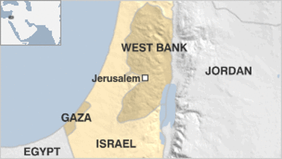

Who is involved?
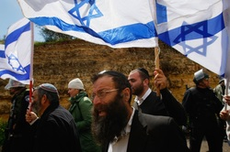
Who are the Israelis?
The Israelis are people living in Israel. They include:
Jews: Jews have religious and historical ties to Israel dating back thousands of years. Many of them migrated from Europe and Russia to escape persecution e.g. after the Holocaust. Some Jews are religious and some are not.
Zionists: Zionism is an ideology that believes that Jews should have their own homeland. Zionists may be either Jewish, Christian or Atheist.
The Zionist movement is a political movement founded by Theodor Herzl in1897. Most of the Israeli government are Zionists. Some Zionist groups are extremists and have carried out terrorist attacks.
Arabs: (Muslim and Christian) About one fifth of the Israeli population are Arabs, descendants of the Palestinians who remained in Israel at its creation, despite the conflict that drove out many of their neighbors.
Who are the Palestinians?
Palestinians are mostly Muslim Arabs, but some are Christian. They also have important religious and historical ties to the area. They live in many countries around the world incl. the Middle East. Many live in the ‘Occupied Territories’ but do not have their own country. Notable groups include:
The PLO: Umbrella political group formed in 1964. Some allied groups are extreme and have carried out terrorist attacks. They’ve also used guerilla tactics against Israel. However, they have now renounced violence and terrorism and been recognized at the political representative of the Palestinians.
The PNA: The governing body of the Palestinian urban centers in the Territories. They were formed in 1994 by the UN. Mahmoud Abbas is the head of both the PNA
and the PLO.
Fatah: The largest faction of the PLO. Some members still associated with ‘terrorist ‘attacks against Israel but now not generally seen as a terrorist organisation. They were ruling party until 2006 when they became seen as corrupt and incompetent. Led by Mahmoud Abbas. Control the West Bank. On-going conflict with Hamas. Not the only political party in the West Bank
Hamas: Formed in 1987 with 2 aims: social welfare and armed resistance. The EU, UK, US and Israel consider it a terrorist organization following suicide bombings and
rocket attacks against Israeli civilians. However, it has earned support from many Palestinians. They won elections in 2006. Led by Ismail Haniya. Control Gaza. Not the only ‘terrorist’ group in Gaza

What are the occupied territories?
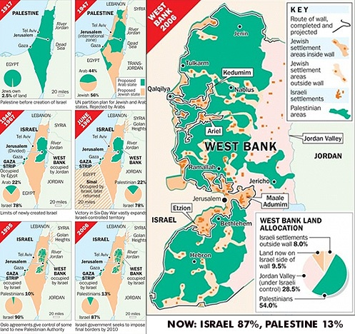
• The West Bank and the Gaza Strip make up the Occupied Territories
• about 3/4s of the world’s countries recognise these areas as ‘Palestine’. However, not the UN or major western nations such as the USA and the UK
• Gaza is ruled by Hamas and The West Bank is ruled by Fatah. However, they have little real power as they are under military occupation

The impacts of the conflict
Social  Restrictions on women’s freedom by Hamas  Poverty  Malnutrition  Unemployment  Residents of Gaza hurt by white phosphorus used by the Israli army buring the victims skin  Damaged homes by shelling  Injuries caused by the Israeli army  Lack of medical facilities  Blockade by the Israeli army makes it difficult to get supplies in. | Economic  Israel has spent $12 billion dollars on the war between 1989 and 2010  Palestinians banned from working in Israel - limited numbers of jobs in Gaza and the West Bank  Many services are run by outside agencies - e.g. the UN  Underground tunnels used to smuggle in goods and guns  Only $60 million of Gaza $540 million budget is generated inside of Gaza - the rest from outside donors  80% live in poverty and 35% are unemployed | Environmental  Contamination of drinking water  Shortage of food production  Limited access to the sea by the Israeli army  Using new fish pond to raise fish for market  Struggling to remove sewage and other waste material - leading the spread of disease

