Latin America Study Guide Name ____________________________
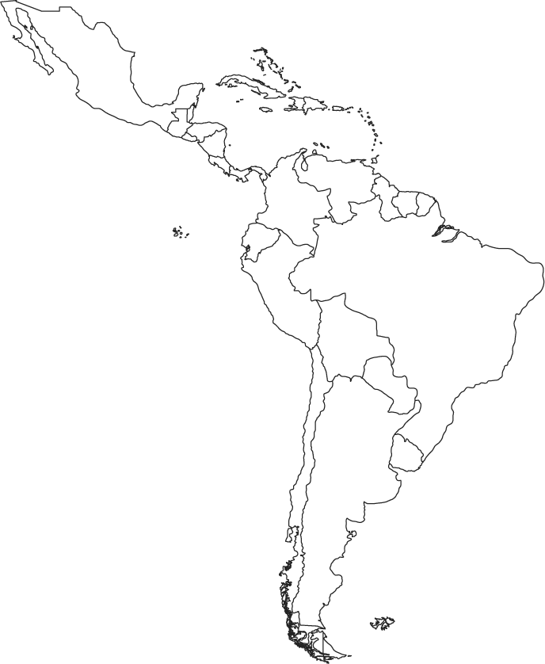

Complete the following:
Label on the Map:
- Circle and label Central America
- Circle and label the Greater and Lesser Antilles
- Circle and label South America
- Label México, Panamá, Brazil, Chile, Cuba, Argentina
- The Caribbean
- Shade in the Amazon rainforest
- Pacific Ocean
- Atlantic Ocean
- Caribbean Sea
- Draw in the Andes Mountains
- Draw the Amazon River
- Identify the world's longest mountain chain, stretching along the west coast of South America:
- The second longest river in the world and one of its three major river systems, running about 4,000 miles from west to east and emptying into the Atlantic ocean:
- A tropical forest, usually of tall, densely growing, trees in an area of high annual rainfall.
- Explain slash and burn farming. Why is this form of farming practiced? Is this effective over a long period of time?
- Explain terrace farming. Why is this practiced? Where specifically throughout Latin America is this practiced?

- Explain the process of deforestation. Why is deforestation occurring? Where is it occurring? What is the rationale for allowing this from the government? What industries benefit from deforestation?

- Explain the purpose of the Panama Canal (include who built and why it was constructed).
- Define canopy.

- Identify the Trans-Andean Highway.
- Explain Vertical Climate Zones (and where would you find them).
- What was the purpose/significance of the Institutional Revolutionary Party in 1929?

- Name the European colonizers of this region. Indicate which areas/countries each European group colonized. Explain the European motivation for colonization of this region.
- When did Mexico achieve independence? Who was an unlikely supporter? Why?

- Identify the cultural legacy Mexico’s colonizers left.
- Identify Mestizo.
- What is a problem facing the Mexican economy?
- What is NAFTA? Who is involved in this organized? What is its purpose? What other organization is it similar to?
- Explain why Central America is considered a cultural hearth.
- Explain the concept of an informal economy.
- Identify the type of music that combines musical elements of Africa, Spain, and the Caribbean?
- Explain where reggae developed and the purpose of the music?
- Describe an oligarchic form of government.
- Identify the significance of the literacy rate in South America compared with other counitres in Latin America.
- Explain the purpose behind the 1494 Treaty of Tordesillas.

- Explain why Brazil is a growing economic power.

- Explain why Brazilian culture is a mixture of native, Portuguese, and African elements?
- Identify Portugal’s cultural legacy in Brazil.
- Explain the impact illegal drug production and trade have had on Latin America and the surrounding nations (U.S.)
Identify the ancient civilization: Maya, Aztec, Inca, or all three
Native language is quechua
Located mainly in Central America and a small part of southern Mexico
Lived in the Andes Mountains
Practiced human sacrifice
Capital was Tenochtitlan (identify the present day city as well)
Conquered by the Spanish
Began in the valley of Mexico
Only known pre-Columbian written language, 365 and ¼ day calendar
Domesticated llamas
Polytheistic
Machu Picchu
Conquered by Hernan Cortes
Conquered by Francisco Pizarro

