Intro to Geography
Maps are important tools in Geography. The word geography comes the Greek word geographia which means “to describe the earth.” Geographers study the world in a different way than do other social scientists. They view the world by looking at the use of pace on the earth and the interactions that take place there. They look for patterns and connections between people and the land that they live on. Geography is the study of the distribution and interaction of physical and human features on the earth.

Methods
Geographers use a variety of tools to study the use of space on Earth. The most common one is a map. Maps are visual representations of a portion of the earth. Maps do not have to be written down to be useful. Since people began roaming the earth, they have created mental maps-maps that they carry in their minds.
Maps that many people are most familiar with appear in printed form, such as in road atlases and books. In recent years, more maps have appeared in electronic media such as the internet, GPS, and on cell phones.
Geographers also use photographs to gain visual evidence about a place. They organize information into charts, graphs, or tables to learn about geographic patterns and to understand changes over time. They may also construct scale models to make study of the real world easier.
Absolute Location
To describe absolute location, geographer’s use a grid system of imaginary lines for precisely locating places not eh earth’s surface. Earth is divided into two equal halves. Each half of the globe is called a hemisphere. Because the earth is round, a hemisphere can be north and south, or east and west. The equator is the imaginary line that divides the north and south halves. The prime meridian is the imaginary line dividing the Greenwich meridian line because the line runs through Greenwich, England.

Question
- What tools are used by geographers?

Latitude Lines
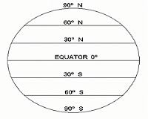
To locate places north or south, geographers use a set of imaginary lines that run parallel to the equator. These lines are called latitude lines. The equator is designated as the zero-degree line for latitude. Lines north of the equator are called north latitude lines, and lines south of the equator are called south latitude lines.
Longitude Lines
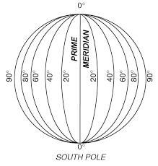
To complete the grid system, geographers use a set of imaginary lines that go around the earth over the poles. The lines, called longitude, mark positions in the east and west hemispheres. The prime meridian is the zero-degree line for longitude.
Each site on the earth can have only one absolute location. To find absolute locations using the grid system, you need to find the point where the latitude and longitude lines cross.
Relative Location
Relative location describes how a place is related to its surrounding environment. You may tell a person that the library is three blocks west of the park. This helps the person find the library.

